Applying Deep Learning Techniques for Audio Pattern Recognitions with AudioMNIST

Svetlana Grabar
grabarsvetlana@cityuniversity.edu
Master of Science, Artificial Intelligence

Jared Graham
grahamjared@cityuniversity.edu
Master of Science, Data Science

Zsolt Kiss
kisszsolt@cityuniversity.edu
Master of Science, Artificial Intelligence

Jan McConnell
janmcconnell@cityuniversity.edu
Master of Science, Data Science

DS620 Machine Learning & Deep Learning (Fall 2025-2026)
School of Technology and Computing
City University of Seattle
Seattle, WA 98121

Abstract

This project explores how deep learning can be used to recognize spoken digits from the AudioMNIST dataset, which comprises thousands of short recordings of numbers spoken by different people. The goal is to find out how well two types of neural networks, convolutional and recurrent, can learn and classify these audio patterns. Spectrograms and visual examples will be used to explain how the networks interpret the sound data. The project will also discuss what factors affect performance, including preprocessing choices, network structure, and overfitting. By the end, the study aims to demonstrate the strengths and limitations of deep learning models for simple speech recognition tasks.

Keywords: Deep learning, speech recognition, audio classification, convolutional neural networks, recurrent neural networks, AudioMNIST, spectrograms.

1. INTRODUCTION

Deep learning has reshaped audio analysis by letting models learn patterns directly from sound. Even simple speech carries differences in pitch, pace, and articulation, which makes spoken digits a practical starting point for studying how neural networks process audio. Details of deep learning fundamentals can be found in Goodfellow, Bengio, and Courville (2016). While the task is small in scope, it shows how well a model can handle natural variation. For an intuitive, concept-driven perspective on neural network behavior, Trask (2019) provides helpful explanations that complement the foundational material. Broader statistical perspectives on pattern recognition, which underpin modern neural modeling, are well documented in Bishop (2006) and help contextualize how these systems interpret structured data.

The AudioMNIST dataset supports this effort with thousands of short recordings of digits spoken by many individuals. Its consistency, combined with speaker-level differences, makes it a useful benchmark for testing how preprocessing, feature choices, and model design affect performance. This project compares two common approaches in speech-related work: convolutional networks that focus on patterns in time-frequency images, and recurrent networks that track how signals change over time. By applying both to log-Mel spectrograms, the study examines how each handles short, structured audio.

The purpose of this introduction is to provide context for the work. Understanding how different model types interpret spoken digits can help inform future efforts in small-scale speech recognition and other settings where data is limited but predictable patterns exist.

2. LITERATURE REVIEW

Speech and audio recognition is a machine learning problem that has many approaches, from Convolutional Neural Networks (CNNs) that use spectrograms to Recurrent Neural Networks (RNNs) that focus on how the sounds change over time. Past research can inform us on the design choices that contribute to model success.

Choosing a dataset is a crucial initial step before starting any machine learning. Becker et al. (2023) introduced the AudioMNIST dataset as a simple benchmark for evaluating deep learning models on audio classification. The dataset consists of 30,000 audio samples of spoken digits. It is meant to be employed as an initial testbed for model development. A related distribution of the dataset is also available on Kaggle (Srinivasan, 2021), though the present project relies on the original AudioMNIST release.

It is necessary to preprocess audio before feeding it into a neural network. The study by Wolf-Monheim (2024) showed that Mel-scaled spectrograms and Mel-frequency cepstral coefficients (MFCCs) performed better than other spectral and rhythm features. Mel-scaled spectrograms achieved a training accuracy of 94.06% and a validation accuracy of 57.50%. MFCCs had similar performance measures. MFCCs were originally introduced for robust audio representation in speech and music research by Logan (2000), and they remain widely used in deep learning pipelines. Short-Time Fourier Transform (STFT) chromograms, Constant-Q Transform (CQT) chromograms, and Chroma Energy Normalized Statistics (CENS) chromograms achieved training accuracies from 79.44% to 70.06% and validation accuracies of 28.25% to 11.50%. This clearly demonstrates the superiority of Mel-scaled spectrograms and MFCCs for audio classification using CNNs.

Zaman et al. (2023) examined several deep learning approaches for audio classification and compared common ways to convert raw audio into learning-ready formats. The study discussed spectrograms, Mel-frequency cepstral coefficients, linear predictive coding, and wavelet-based methods as typical feature choices. Once transformed, the audio was processed by different model types, including CNNs, RNNs, autoencoders, transformers, and hybrid designs. CNNs performed well because they capture local time-frequency patterns, while RNNs were effective for sequential structure. Autoencoders supported unsupervised learning, and transformer-based models showed strong potential for future audio work. The overall takeaway is that both the feature representation and the model type strongly influence classification performance.

Jeong, S.-M., Kim, S., Lee, E. C., & Kim, H. J. (2024) focused on spectrogram-based speech classification and evaluated two modern architectures: the Audio Spectrogram Transformer (AST) and a CNN-based Patch Shift, Layer Scale, and Aggregation (PSLA) model. These models have recently outperformed traditional CNNs on several speech tasks, suggesting that transformer-based and hybrid methods are becoming increasingly competitive for audio analysis. Their findings highlight an ongoing shift toward architectures that can capture broader context and more complex time-frequency relationships.

3. METHODOLOGY

The AudioMNIST dataset consists of 30,000 short audio recordings of spoken digits (0-9) from multiple speakers, which were converted into a uniform format before training. The preprocessing pipeline transformed raw .wav audio signals into log-scaled Mel spectrograms using the librosa library. This representation captures both temporal and frequency features of speech while approximating the human auditory scale.

To standardize input for the neural network, the spectrograms were normalized and verified using a dedicated checking script (check_features.py). A custom dataset class (dataset.py) handled the organization of features and labels into PyTorch-compatible tensors, including right-padding for variable-length sequences. The data was then divided into training, validation, and test splits to ensure consistent evaluation.

The pipeline ensured that each sample contributed balanced information across speakers and digits.

The overall process included:

- Loading and trimming audio to remove silence
- Extracting Mel-frequency spectrograms
- Applying logarithmic scaling and normalization
- Validating indexing and feature structure
- Building training, validation, and test loaders with batch-wise collation
This systematic preprocessing produced stable inputs for both the CNN and RNN models and reduced noise-related variation that could otherwise disrupt learning.

4. MODEL FORMULATION

The primary model used is defined in the file cnn_model.py within the team GitHub repository (McConnell, Grabar, Graham, & Kiss, 2025). CNNs are well suited to 2D time-frequency data such as spectrograms because they can detect localized patterns (e.g., formants, harmonics) through shared convolutional filters. Practical guidance on structuring convolutional layers, activation functions, and training workflows can be found in Géron (2019), whose recommendations align with the architectural choices used here.

The network design included:

- Two convolutional layers with ReLU activation and batch normalization as introduced by Ioffe and Szegedy (2015)
- Max pooling after each convolution to reduce spatial dimensions
- Dropout regularization to mitigate overfitting (Srivastava, N., Hinton, G., Krizhevsky, A., Sutskever, I., & Salakhutdinov, R., 2014)
- Fully connected dense layers leading to a 10-class softmax output for digit classification

Training was performed using the Adam optimizer (Kingma & Ba, 2015) with an initial learning rate of 0.0003, dynamically reduced after plateauing epochs. The cross-entropy loss function was used as the objective criterion. Checkpoints were saved after each epoch to allow resuming and selection of the best-performing model based on validation accuracy.

The model was initially trained for 10 epochs to confirm pipeline stability, and then training resumed from the checkpoint for an additional 30 epochs, totaling 40 training epochs. Learning rate scheduling and checkpointing helped stabilize convergence and control overfitting. The best model was identified at epoch 28, achieving the highest validation accuracy.

This architecture served as the initial reference model for evaluating how a CNN processes log-Mel spectrogram features for spoken-digit classification.

5. DATA AND RESULTS

The final CNN achieved a validation accuracy of 80.6 % and a test accuracy of 80.7 %. Training accuracy gradually improved from 58 % to 69 %, indicating steady learning without memorization of the training data. The validation accuracy curve showed consistent improvement, peaking near epoch 28 before stabilizing, which suggests balanced generalization and minimal overfitting.

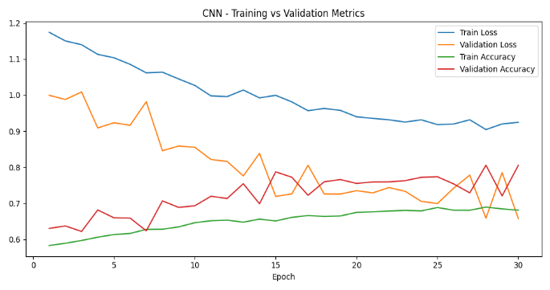
Figure 5.1: CNN Training and Validation Metrics

Metric | Value
Best Epoch | 28
Training Accuracy (final) | 68.9 %
Validation Accuracy (best) | 80.6 %
Test Accuracy | 80.7 %
Final Validation Loss | 0.658
Optimizer | Adam
Learning Rate Schedule | 0.0003 → 0.000009
Total Epochs | 40  (10 initial + 30 resumed)
Table 5.1: Key performance metrics for the baseline CNN, including accuracy, loss, learning-rate schedule, and major hyperparameters.

Overall, the CNN effectively learned robust time-frequency features for spoken digit classification.

The use of log-Mel spectrograms and progressive learning rate decay contributed to stable convergence. The model demonstrated good performance for a compact architecture, highlighting the suitability of convolutional approaches for small-scale audio pattern recognition tasks such as AudioMNIST.

6. REVISED MODEL FORMULATION

Two independent convolutional neural network (CNN) architectures were developed for the AudioMNIST classification task. Although both models used convolutional feature extraction on log-Mel spectrograms, their design choices differed in ways that affected robustness and generalization. This parallel exploration made it possible to compare preprocessing strategies, normalization methods, and architectural depth within the same dataset and task.

One CNN implementation used per-sample normalization, dynamic right-padding for variable-length inputs, and a compact three-block convolution-batch normalization-pooling structure. A second CNN expanded on these ideas by introducing fixed-length spectrogram preprocessing and dataset-level Cepstral Mean and Variance Normalization (CMVN), which provided more consistent input statistics. Additional enhancements included data augmentation through multi-mask SpecAugment, mild time-stretching, and low-level additive noise to improve resilience to recording variability. Architectural scaling to 32-64-128 convolutional channels, combined with tuned dropout rates, increased representational capacity without encouraging overfitting. Adaptive learning rate scheduling and early stopping further stabilized convergence and ensured that the best weights were retained for evaluation.

Together, these refinements produced a more stable training process and higher validation accuracy. The comparison highlights how targeted normalization, controlled augmentation, and careful architectural scaling can significantly improve performance on small-scale audio classification tasks such as AudioMNIST.

7. RESULTS

Three models were evaluated on the AudioMNIST dataset: the baseline CNN, the improved CNN, and the RNN baseline. Their performance differed substantially in stability, accuracy, and ability to generalize from speaker variability. Figures and metrics below summarize each model’s behavior.

7.1 Baseline CNN Performance
The baseline CNN achieved a validation accuracy of 80.6 percent and a test accuracy of 80.7 percent. Training accuracy increased steadily, ending at 68.9 percent, which indicates modest underfitting. The training and validation accuracy curves (Figure 7.1) show gradual improvement in training accuracy and fluctuating validation accuracy, consistent with the model’s limited depth.

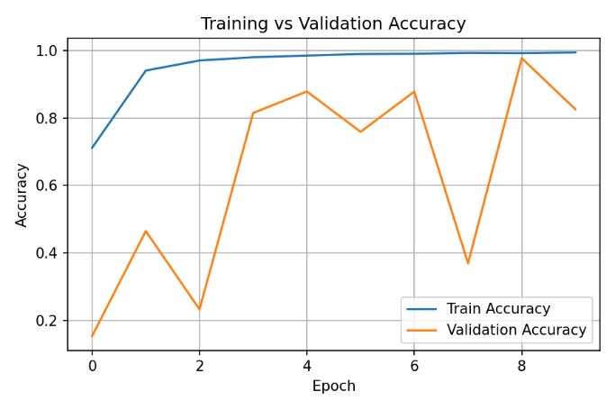
Figure 7.1: Baseline CNN Training vs. Validation Accuracy.

The loss curves (Figure 7.2) show smooth reduction in training loss with significant variability in validation loss. This instability reflects the baseline model’s sensitivity to differences in pronunciation, recording clarity, and speaker characteristics.

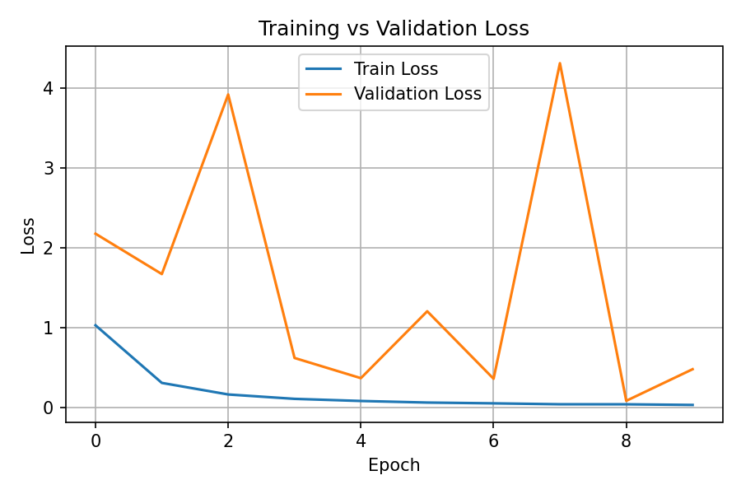
Figure 7.2: Baseline CNN Training vs. Validation Loss.

A confusion matrix (Figure 7.3) highlights several off-diagonal errors, particularly among acoustically similar digits such as 4, 5, and 9.

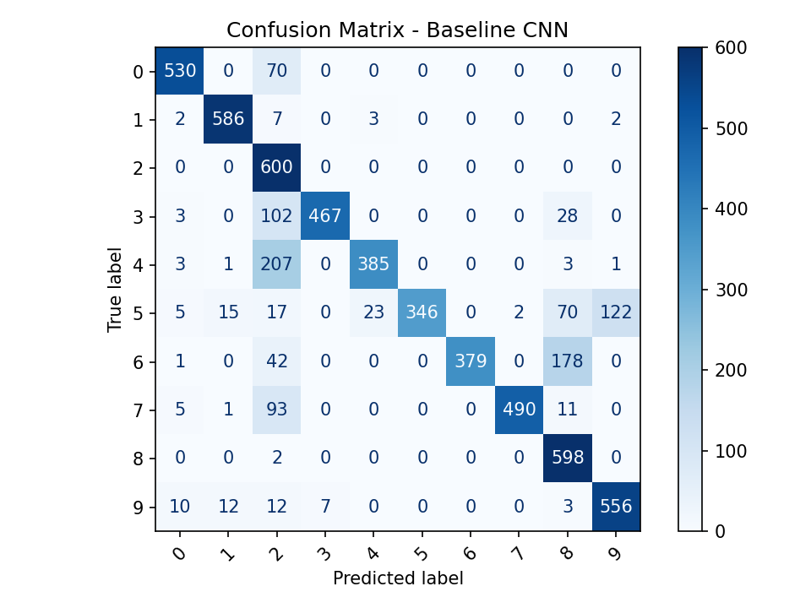
Figure 7.3: Confusion Matrix for the Baseline CNN.

A single set of representative predictions (Figure 7.4) was generated using a fixed group of test samples. These examples illustrate typical correct and incorrect classifications. The same samples are used later for the improved CNN to allow consistent qualitative comparison.

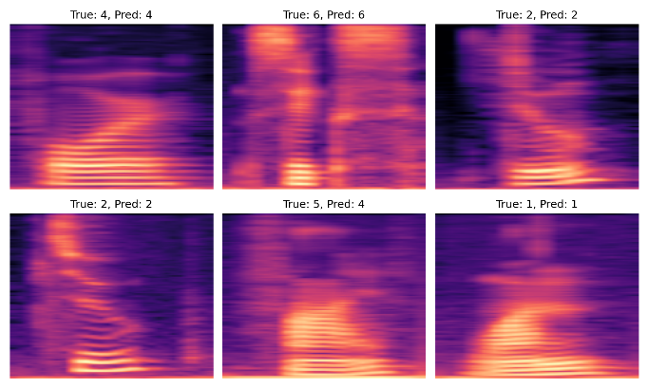
Figure 7.4: Baseline CNN Sample Correct and Incorrect Predictions.

7.2 Improved CNN Performance
The improved CNN demonstrated significantly stronger performance. With fixed-length preprocessing, mean-variance normalization, and controlled data augmentation, the model surpassed 90 percent validation accuracy. Training curves (Figure 7.5) show a cleaner trajectory, with smaller gaps between training and validation accuracy.

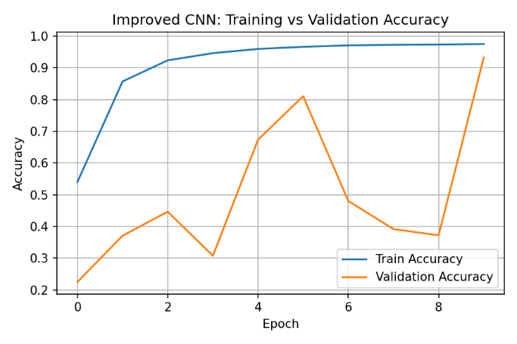
Figure 7.5: Improved CNN Training vs. Validation Accuracy.

Loss curves (Figure 7.6) also show improved stability, with reduced volatility in validation loss and smoother convergence relative to the baseline.

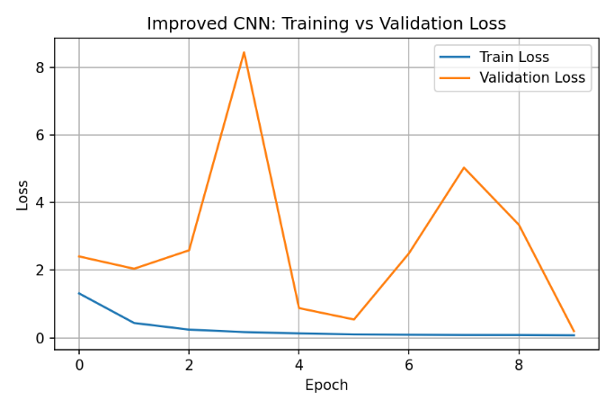
Figure 7.6: Improved CNN Training vs. Validation Loss.

The confusion matrix (Figure 7.7) shows a substantial reduction in errors across nearly all digits. The improved model corrected many of the baseline CNN’s systematic misclassifications, especially among digits with overlapping spectral characteristics.

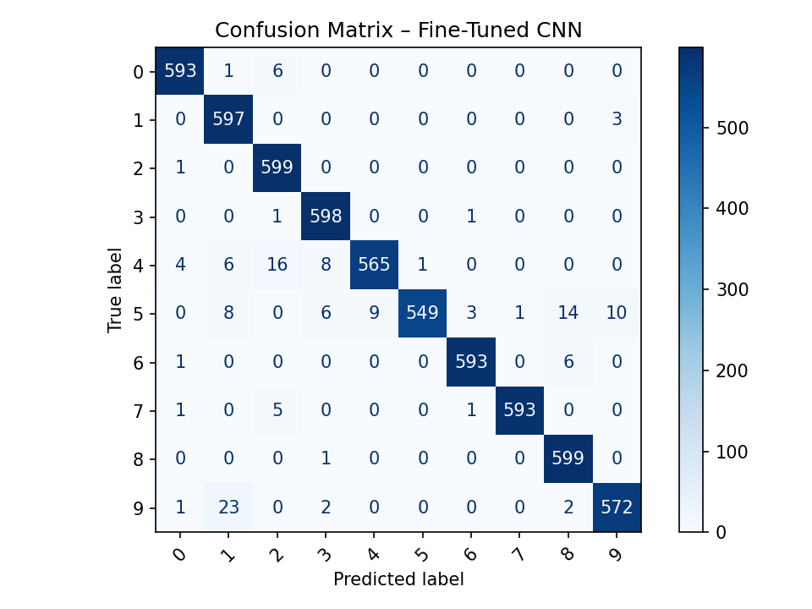
Figure 7.7: Confusion Matrix for the Improved CNN.

7.3 RNN Baseline Performance
The RNN baseline achieved the strongest overall performance. Using bidirectional Gated Recurrent Unit (GRU) layers to capture temporal structure, the model reached:

- 99.9 percent training accuracy
- 98.7 percent validation accuracy
- 99.2 percent test accuracy

Training and validation accuracy curves (Figure 7.8) show rapid convergence within the first few epochs, followed by stable alignment between the two curves.

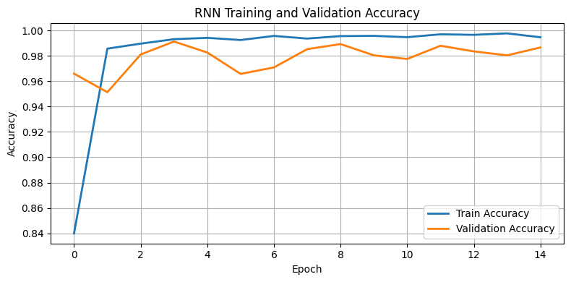
Figure 7.8: RNN - Training vs. Validation Accuracy.

The loss curves (Figure 7.9) show minimal divergence and sustained low validation loss, indicating strong generalization and very low overfitting.

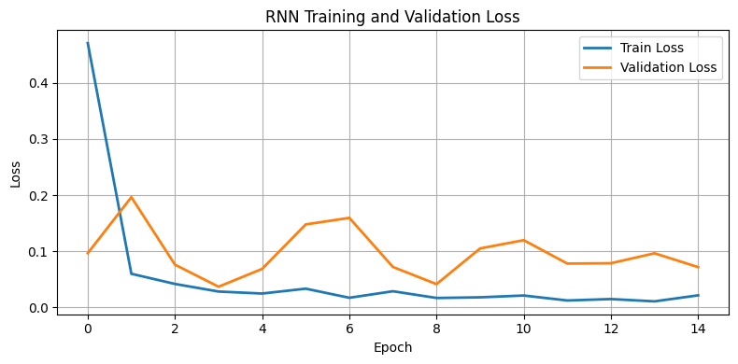
Figure 7.9: RNN - Training vs. Validation Loss.

The confusion matrix (Figure 7.10) confirms the model’s near-perfect performance, with almost all predictions falling along the diagonal. Errors were sparse and typically involved low-energy samples or near-silent recordings.

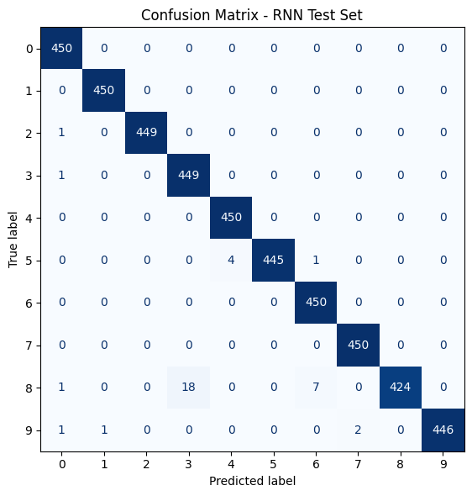
Figure 7.10: Confusion Matrix for the RNN Baseline.

7.4 Summary of Model Performance
The models followed a clear performance hierarchy:

- RNN Baseline: highest accuracy and best generalization
- Improved CNN: strong performance with stable convergence
- Baseline CNN: moderate performance and higher variance

These results demonstrate that:

- CNNs learn meaningful spectral features but benefit significantly from normalization, fixed-length inputs, and augmentation.
- RNNs excel when temporal structure carries important discriminative information, as in short spoken-digit recordings.

Together, these experiments provide a comparative picture of how different deep learning architectures handle small-scale audio classification tasks (Purwins, Li, Virtanen, Schlüter, Chang, & Sainath, 2019).

8. DISCUSSION AND LIMITATIONS

8.1 DISCUSSION

The results show clear differences in how each model handled the spoken-digit recordings. The baseline CNN performed reasonably well, but the validation curve shifted more than expected. That kind of fluctuation usually means the model is reacting to small variations in speaker behavior or recording clarity rather than learning stable patterns. This matches prior work that stresses the need for careful preprocessing and stronger feature control when using shallow convolutional models for audio.

The improved CNN handled these issues better. Once we introduced fixed-length inputs, CMVN, and realistic augmentation, the training process became more stable and the accuracy increased. These steps are fairly common in audio processing, and our results reinforce why they matter. The deeper architecture and better-tuned dropout also added stability. This is consistent with the practical recommendations provided by Géron (2019) and the original dropout research by Srivastava et al. (2014).

The RNN baseline delivered the strongest overall results. The bidirectional GRU layers follow the audio through time, so the model learns patterns that are difficult for a purely convolutional network to capture. In our experiments, this gave the RNN a major advantage. The confusion matrix shows very few mistakes. This aligns with prior research on audio sequence modeling by Purwins et al. (2019), which notes that temporal models often excel when the signal contains clear sequential structure. Spoken digits fit that description well.

Overall, comparing the models side by side highlights what each one learns. The CNNs pay close attention to the visual structure of the spectrogram, while the RNN focuses on how the sound changes through time. Both offer useful perspectives, but for short and structured recordings, the temporal model clearly performed better.

8.2 LIMITATIONS

Several limitations need to be considered when interpreting the findings. AudioMNIST is a clean and highly constrained dataset. The recordings are short, isolated digits spoken in quiet settings. Real-world audio is rarely this controlled. Background noise, accents, microphone differences, and overlapping signals all introduce variation that our models were not tested against.

The dataset’s narrow scope also limits generalization. Although 30,000 samples is a healthy number, the recordings cover only ten classes and follow a very consistent format. A more diverse dataset would place different demands on the CNNs and might expose weaknesses in the RNN, especially in situations with inconsistent timing or varied speaking styles.

We also evaluated a limited set of architectures. The CNNs used here were relatively simple, and we implemented only one RNN configuration. More complex designs such as deeper convolutional stacks, transformer-based models such as AST, or hybrid combinations might produce different results. We did not perform an exhaustive hyperparameter search due to time and resource constraints, so the results may not represent the best possible performance for each model type.

Finally, our evaluation focused primarily on accuracy and loss. Additional metrics such as precision, recall, per-speaker performance, or sensitivity to quieter inputs could provide a more detailed understanding of model behavior.

Even with these constraints, the project offers a clear and practical comparison of convolutional and recurrent architectures on structured speech. It also provides a solid starting point for future work on more complex audio classification problems.

9. CONCLUSION

The project set out to compare how different deep learning models handle spoken-digit recordings, and the results showed clear distinctions in what each model learned. The baseline CNN reached reasonable accuracy, but its shifting validation pattern suggested that the architecture had trouble dealing with normal variation in how people speak. Strengthening the preprocessing steps and adjusting the architecture improved its performance, which confirmed that small changes in how audio is prepared can have a noticeable effect on the final outcome.

The RNN baseline stood out in this comparison. Because it follows the signal through time, it was able to capture patterns the CNNs did not. This led to higher accuracy and far fewer classification errors. For short and consistent recordings such as digits, the ability to track temporal structure proved especially valuable.

While the dataset was controlled and limited in scope, the side-by-side comparison of CNNs and an RNN highlighted how each model interprets audio. CNNs focus on local structure in the spectrogram, and RNNs pay attention to how the sound evolves. Both perspectives are useful, but for this task the temporal model showed a clear advantage. These results provide a practical starting point for future work that involves noisier environments, more varied speech, or larger vocabularies.

10. REFERENCES
Becker, S., Vielhaben, J., Ackermann, M., Müller, K.-R., Lapuschkin, S., & Samek, W. (2023). AudioMNIST: Exploring explainable artificial intelligence for audio analysis on a simple benchmark. Journal of the Franklin Institute. Advance online publication. https://doi.org/10.48550/arXiv.1807.03418
Bishop, C. M. (2006). Pattern recognition and machine learning. Springer.
Géron, A. (2019). Hands-on machine learning with Scikit-Learn, Keras, and TensorFlow (2nd ed.). O’Reilly Media.
Goodfellow, I., Bengio, Y., & Courville, A. (2016). Deep learning. MIT Press.
Ioffe, S., & Szegedy, C. (2015). Batch normalization: Accelerating deep network training by reducing internal covariate shift. Proceedings of the 32nd International Conference on Machine Learning (ICML 2015) (pp. 448-456).
Jeong, S.-M., Kim, S., Lee, E. C., & Kim, H. J. (2024, July 17). Exploring Spectrogram-Based Audio Classification for Parkinson’s Disease: A Study on Speech Classification and Qualitative Reliability Verification. MDPI. https://www.mdpi.com/1424-8220/24/14/4625
Kingma, D. P., & Ba, J. (2015). Adam: A method for stochastic optimization. arXiv preprint arXiv:1412.6980. https://doi.org/10.48550/arXiv.1412.6980
Logan, B. (2000). Mel frequency cepstral coefficients for music modeling. Proceedings of the International Symposium on Music Information Retrieval (ISMIR 2000), 23-25.
McConnell, J., Grabar, S., Graham, J., & Kiss, Z. (2025). DS620 team project: Applying deep learning techniques for audio pattern recognition with AudioMNIST [Computer software]. GitHub. https://github.com/janmcconnellCityU/DS620_Team_Project
Purwins, H., Li, B., Virtanen, T., Schlüter, J., Chang, S.-Y., & Sainath, T. (2019). Deep learning for audio signal processing. IEEE Journal of Selected Topics in Signal Processing, 13(2), 206-219. https://doi.org/10.1109/JSTSP.2019.2908700
Srinivasan, S. (2021). Audio MNIST dataset [Data set]. Kaggle. Retrieved October 12, 2025, from https://www.kaggle.com/datasets/sripaadsrinivasan/audio-mnist
Srivastava, N., Hinton, G., Krizhevsky, A., Sutskever, I., & Salakhutdinov, R. (2014). Dropout: A simple way to prevent neural networks from overfitting. Journal of Machine Learning Research, 15(1), 1929-1958.
Trask, A. W. (2019). Grokking deep learning. Manning Publications.
Wolf-Monheim, F. (2024, October 9). Spectral and rhythm features for audio classification with deep convolutional Neural Networks. https://arxiv.org/html/2410.06927v1
Zaman, K., Sah, M., & Direkoglu, C. (2023, January). A Survey of Audio Classification Using Deep Learning. ResearchGate. https://www.researchgate.net/publication/374101086_A_Survey_of_Audio_Classification_using_Deep_Learning

